**Week 9 – Challenge Lab: Implementing a Serverless Architecture for the Café**

**Name: Tong Duc Tu Tam**

**Student ID: 104775085**

**Date: 11/07/2024**

**Task 1: Downloading the source code**

**Task 2: Creating the DataExtractor Lambda function in the VPC**

Figure 1: Create security group for lambda function.

Figure 2: Update DatabaseSG.

Figure 3: Create Lambda Function.

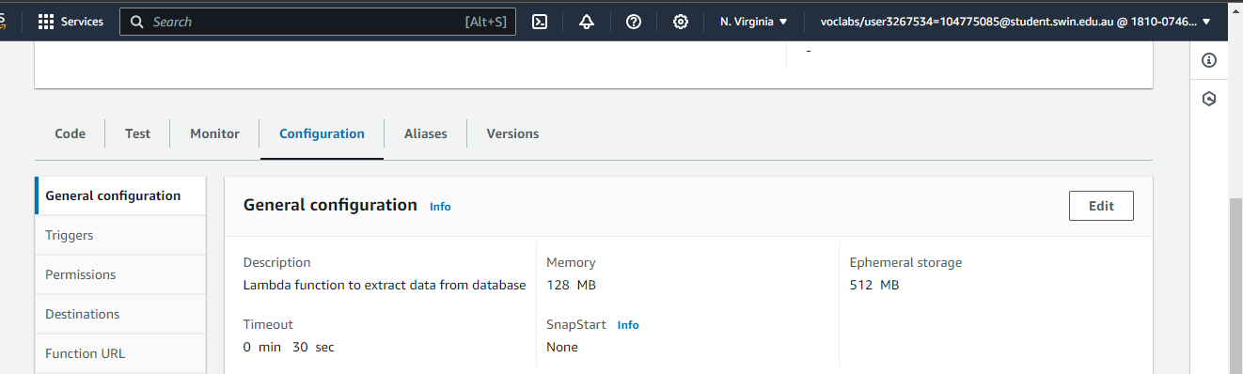

Figure 4: Configure basic information of Lambda function.

Figure 5: Config Lambda handler.

**Task 3: Creating the SalesAnalysisReport Lambda function**

Figure 6: Create another Lambda function.

**Task 4: Creating an SNS topic**

Figure 7: Create SNS topic.

Figure 8: Edit environment variables.

**Task 5: Creating an email subscription to the SNS topic**

Figure 9: Create email subscription.

Figure 10: Confirm subscription.

**Task 6: Testing the salesAnalysisReport Lambda function**

Figure 11: Email notification

**Task 7: Setting up an Amazon EventBridge event to initiate the Lambda function each day**

Figure 12: Created EventBridge Rule.

Figure 9: Score after submission.

Figure 10: Submission report.